**The Tuesday Troubles**

Tuesday May 11, 2021

Three Little Pigs Paying the Price

By Loz Mckenzie

In Three Little Pigs a wolf comes to eat each little pig but the last pig survives until Little Red Riding Hood comes. The first little pig is very dumb building his house out of straw and pays the price when a wolf comes. The second little pig is brighter than the first but only a little. He pays the same price. He builds his out of twigs but still can not escape the wolf’s hungry wrath. The third little pig is the smartest of all; he builds his out of bricks but the wolf is quick.

The wolf spots the pig's house and tries to blow his house down but in the end he is blown down. He gets an idea blowing the pig’s house down with dynamite at midnight. The pig is scared so he calls Little Red Riding Hood she says she will be down to his house. The pig is in fear but not to worry Little Red Riding Hood is here. The wolf is shot dead now. The pig is happy but little does he know he made a big mistake and dies for it.

People say Little Red Riding Hood is a very nice girl but she has killed 2 wolves and one innocent little pig. Pigs have not been seen since and no one should trust evil Little Red Riding Hood. It started just by a wolf who ate two little pigs. But then a girl comes and shoots him. Then kills the final pig just for a skin. Moral never trust Little Red Riding Hood or wolves but mostly never trust Little Red Riding Hood. Three pigs had their whole life ahead of them but now 3 are dead and a wolf as well except for Little Red Riding Hood who is still alive.

Stay tuned for our next newspaper article next Tuesday.

The Tuesday Troubles is always with you.

One person reported that pigs were killed by Little Red Riding Hood! Another person quoted “I am not surprised this happens all the time when asked about the incident.”

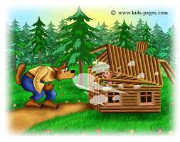

The wolf is blowing down the little pigs house that is made out of twigs.